***Golden Rules***

[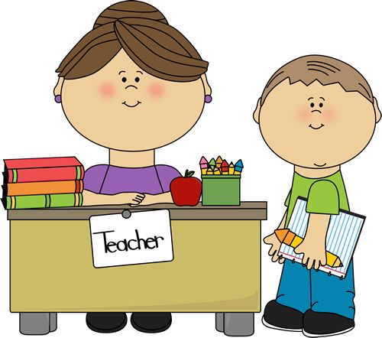](http://www.google.co.uk/url?sa=i&rct=j&q=&esrc=s&source=images&cd=&ved=2ahUKEwid5qvJusjkAhWjuXEKHZoCBzAQjRx6BAgBEAQ&url=http://dubeat.com/2018/01/my-experience-of-tutoring-young-students/&psig=AOvVaw2NtqpmxcOi4Eg74LT8yywP&ust=1568280537408586)[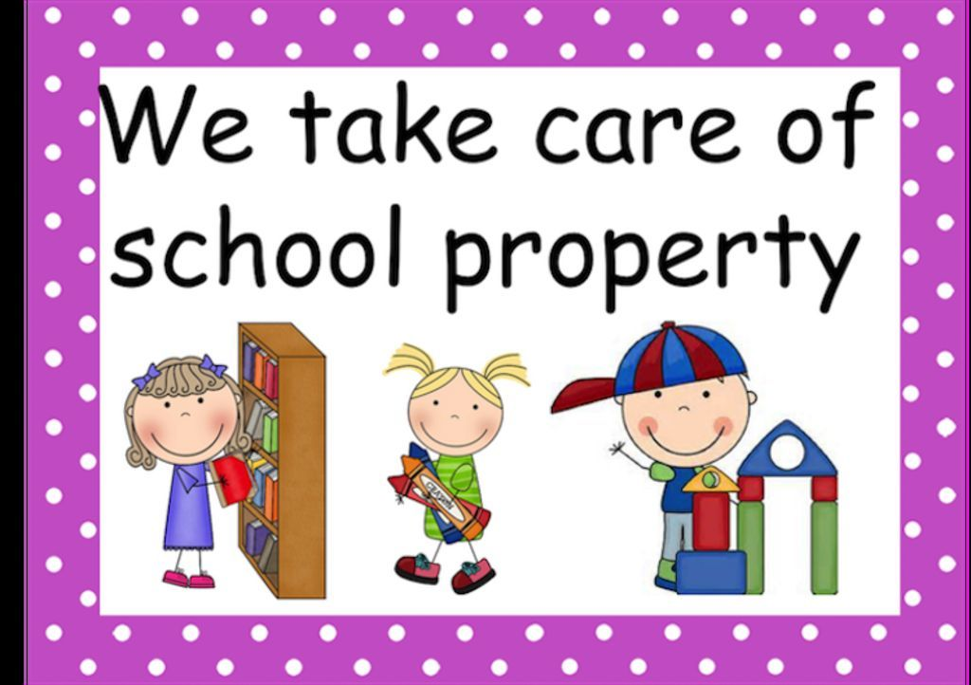](https://www.google.co.uk/url?sa=i&rct=j&q=&esrc=s&source=images&cd=&ved=2ahUKEwiynva7w8jkAhWXSRUIHeRMB6QQjRx6BAgBEAQ&url=https://www.beps.com/about-us/our-values/golden-rules&psig=AOvVaw2FTGqq97Ib0E2SLkeAtC3y&ust=1568282956657889)[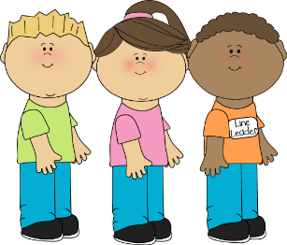](http://www.google.co.uk/url?sa=i&rct=j&q=&esrc=s&source=images&cd=&cad=rja&uact=8&ved=&url=/url?sa%3Di%26rct%3Dj%26q%3D%26esrc%3Ds%26source%3Dimages%26cd%3D%26ved%3D%26url%3Dhttps%3A%2F%2Fomaharentalads.com%2Fexplore%2Fline-leader-clipart%2F%26psig%3DAOvVaw2NtqpmxcOi4Eg74LT8yywP%26ust%3D1568280537408586&psig=AOvVaw2NtqpmxcOi4Eg74LT8yywP&ust=1568280537408586)[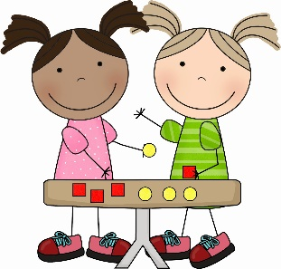](https://clipartion.com/free-clipart-29155/)[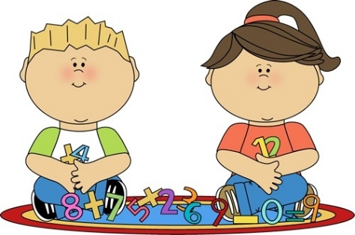](http://www.google.co.uk/url?sa=i&rct=j&q=&esrc=s&source=images&cd=&cad=rja&uact=8&ved=2ahUKEwid5qvJusjkAhWjuXEKHZoCBzAQjRx6BAgBEAQ&url=http://www.google.co.uk/url?sa%3Di%26rct%3Dj%26q%3D%26esrc%3Ds%26source%3Dimages%26cd%3D%26ved%3D2ahUKEwid5qvJusjkAhWjuXEKHZoCBzAQjRx6BAgBEAQ%26url%3Dhttp%3A%2F%2Fwww.attachmax.com%2F00%2FpostXVII%2Fkeep-your-hands-and-feet-to-yourself-clipart.html%2Fclassroom-keep-your-hands-to-yourself-clipart-with-regard-to-keep-your-hands-and-feet-to-yourself-clipart%26psig%3DAOvVaw2NtqpmxcOi4Eg74LT8yywP%26ust%3D1568280537408586&psig=AOvVaw2NtqpmxcOi4Eg74LT8yywP&ust=1568280537408586)

We listen and follow instructions

We are kind, helpful and honest

We are gentle

We look after property

We work hard