**I will always**

[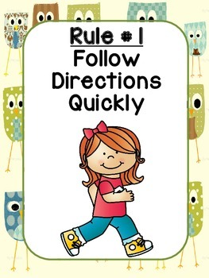](http://www.google.co.uk/url?sa=i&rct=j&q=&esrc=s&source=images&cd=&cad=rja&uact=8&ved=&url=/url?sa%3Di%26rct%3Dj%26q%3D%26esrc%3Ds%26source%3Dimages%26cd%3D%26ved%3D%26url%3Dhttps://www.teacherspayteachers.com/Product/Classroom-Rules-with-Owl-Background-1995577%26psig%3DAOvVaw0_UmaxUQw9DPtWujBduWWH%26ust%3D1567759451573350&psig=AOvVaw0_UmaxUQw9DPtWujBduWWH&ust=1567759451573350)[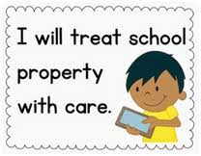](http://www.google.co.uk/url?sa=i&rct=j&q=&esrc=s&source=images&cd=&ved=2ahUKEwi2i6fGpLnkAhXIzoUKHaV9DPsQjRx6BAgBEAQ&url=http://www.hudsonschoolmuzaffarpur.in/care-school-property.php&psig=AOvVaw2xSdJXMOw3ypvbaaYOL2aH&ust=1567759251571958)[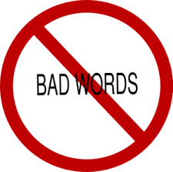](https://www.google.co.uk/url?sa=i&rct=j&q=&esrc=s&source=images&cd=&cad=rja&uact=8&ved=2ahUKEwjSvtH-o7nkAhUOTBoKHQiRDEEQjRx6BAgBEAQ&url=https://es.english-attack.com/vocabexpression/watch-your-tongue&psig=AOvVaw0v-CEzXpgwJd1dd6aMDn4R&ust=1567759045318892)[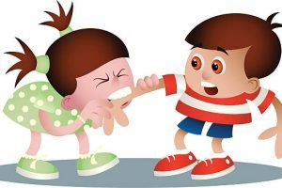](http://clipartportal.com/category/c-clipart-photo-download/page/10481/)

White Slips

Follow instructions

Not hurt another child in any way

e.g. name calling, hitting

Take care of property

Use appropriate language