Parenting NI will be providing a 1 hour zoom session – **Top Tips for Promoting a Healthy Lifestyle** for parents/guardians.  This short session will touch on elements such as diet, exercise, sleep and how these impact on healthy physical and mental health.

There are two dates that parents can choose from:

**Monday 27th February from 7-8pm** or **Tuesday 28th February from 7-8pm**.

**If any parent/guardian would like to book a space they just need to call our support line on 0808 8010 722**.

**Kelly Barbour**

**Parenting Support & Programme Coordinator**

**Working hours: Monday (9am-4.45pm); Tuesday (9.45am – 2.15pm) & Wednesday (9am – 4.45pm)**



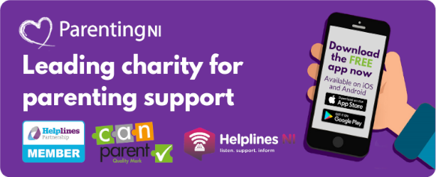

**Parenting NI . First Floor, Unit 3, Hawthorn Office Park, 39a Stockman's Way, Belfast, BT9 7ET, Northern Ireland  
Head Office +44 (0)28 9031 0891  Support Line 0808 8010 722  
Web**[**www.parentingni.org**](http://www.parentingni.org/)[](http://facebook.com/ParentingNI)[](http://twitter.com/ParentingNI)[](http://www.instagram.com/parentingni)